**Soldering station**

|  |  |
| --- | --- |
| Author | Jonas Vanhulst |

Content

1 Introduction 3

2 Material and methods 4

2.1 Material 4

2.1.1 Comparing of components 4

2.1.2 Used Software 5

2.1.3 Bill of materials 6

2.2 Methods 7

2.2.1 Route representation 7

3 Results 8

3.1 Functionality Electrical schematic’s 8

3.1.1 Power source 8

3.1.2 Pulse width modulation 9

3.1.3 Microprocessor 10

3.1.4 Display 11

3.1.5 Thermocouple 12

3.2 PCB Design 13

3.2.1 Display 13

3.2.2 Processor 13

3.2.3 3D view 14

3.3 Case Design 15

3.3.1 Case 15

3.3.2 Case and PCB assembly 15

4 Discussion 15

5 Reference list 15

Image Content

Figure 1 Bill of materials 6

Figure 2 Route representation 7

Figure 3 Schematic power source 8

Figure 4: Schematic_Design_Pulse_width_modulation 9

Figure 5 Schematic Design Microprocessor 10

Figure 9: PCB_Design_Processor 13

Figure 11 3D_Render_Processor 14

# Introduction

This application note describes the building of a soldering station from scratch. Thanks to the Elector mag-azine, it was easier to start. The main goal was to let ELECTRONICS-ICT students learn how to work and use some products inclusive software. The main characteristics of a soldering station are that this device will heat up very fast. This effect was created by the chosen soldering iron and its toroidal transformer. In my case, the Weller iron would be supplied by a 60VA transformer. More about this will follow in this note. After assembling this soldering station, it will be used to solder electronic components on a PCB (Printed circuit board).

Firstly, the used choices about through hole and SMD-components will be explained, further there is a complete overview. At the end of this application note, there will be a discussion about the results and the references used.

# Material and methods

## Material

### Comparing of components

At the start of this project, the chose between Trough hole and SMD components begins. This choise will be very essential by designing the PCB.

Before placing the order and make the final decission, the reaction to look at home wich components are in stock was a good idea. After checking all the components, the decission to do only the resistor’s and capacitor’s in SMD was made. This decision was made by the fact that a lot of spare parts were available at home in Through hole.

By ordering the components, better look to the delivery date these days. By this very important fact the orders were placed at Farnell, Amazon, TME and RS-components. This manufactures have a realy fast delivery date and the prices were also acceptable. By ordering in Europe, the tax and the delivery costs will be higher than you will order in China. But due these days the risk by delivering or not, wasn’t the best plan while working with a small deadline.

### Used Software

#### Altium Designer

All the design of the PCB was done with Altium Designer. The school gave us this strong program used by professionals in the work field. Also, there were a lot of problems finding the right parts and footprints. Some parts are just too old to find in the current database. By requesting those components from Ultra Librarian, the old components could be placed.

#### Fushion 360

Fusion 360 is a cloud-based 3D modelling program. In this software you are allowed to modelling CAD,CAM,CAE and also to do PCB design. By importing the 3D-PCB designed from Altium Designer, I could fit the PCB into the case. This is very useful for avoiding problems while testing the final result.

#### Prusaslicer

The Prusaslicer is an open-source tool to export your designed print files for your 3D printer. At home, I have an Prusa Ultimate MK3S+. This is an fantastic / cheap printer were the case was printed. The fine tuning was made by the brand new SuperPINDA probe of Prusa. The advantage to have an own printer resulted in no queues to print on campus and that I could print always several prototypes.

### Bill of materials

By ordering the components, it was a good idea to ask to the teacher which components are available for all the students. Also asking by my family for some parts, resulted that the order-list was reduced. This isn’t only an advantage for me but also to avoid duplication of components and unnecessary costs.

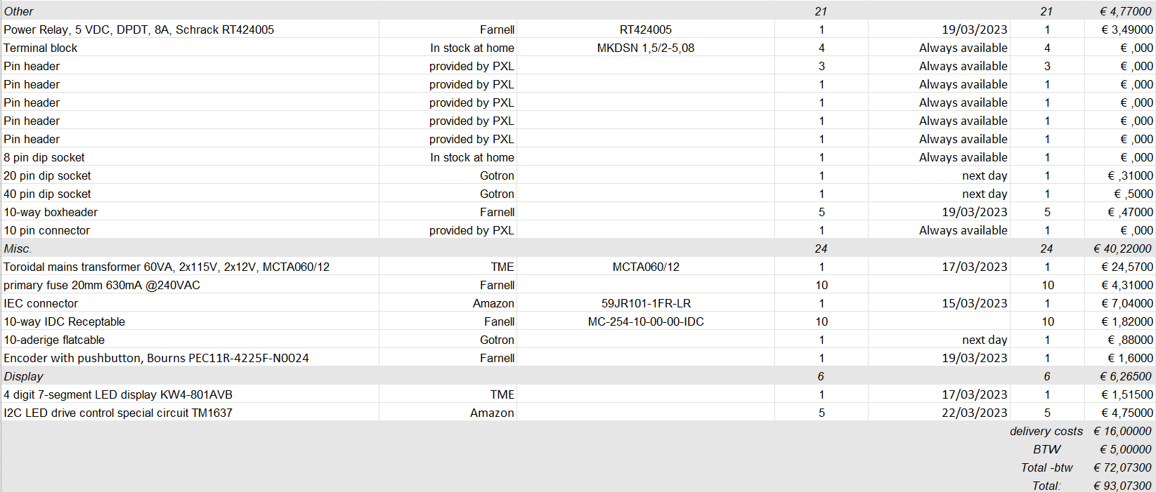

Figure 1: Bill_of_materials

Figure 1 Bill of materials

## Methods

### Route representation

In figure 2, a complete overview of the project is displayed. By starting the project, analysing the project and downloading the recommended software are the first things to do. By ordering the components the search for footprints begins.

Figure 2 Route representation

# Results

## Functionality Electrical schematic’s

### Power source

The soldering station will be supplied by one toroidal transformer (2 x 12V, 60VA). The secondary windings will be connected to connector K1 and K2. The two bridge rectifiers (B1 and B2), are connected with capacitors C1 and C4. This results in a stable and smoothing circuit. The Zener diode D2 is placed for high voltage protection. The two off sheet connectors are placed to create a clear schematic and are connected to the microcontroller.

Figure 3 Schematic power source

### Pulse width modulation

The pulse width modulaton circuit is important by placing the IC2. This integrated circuit will reinforce the current voltage and the connection for the tempature sensor. By placing this component it’s important to see that the part will have 5V input voltage and ground. In that little circuit are two capacitors placed to reduice the noise in the circuit. Those need to be placed as close as possible by the IC2.

Figure 4: Schematic_Design_Pulse_width_modulation

### Microprocessor

By looking at this schematic, you see that everything is connected at the microprocessor. The connector K12 is used to connect the display print to the microprocessor print. This will be done with a flatcable. This gives you the oppurtunity to place the display were the users prefers.

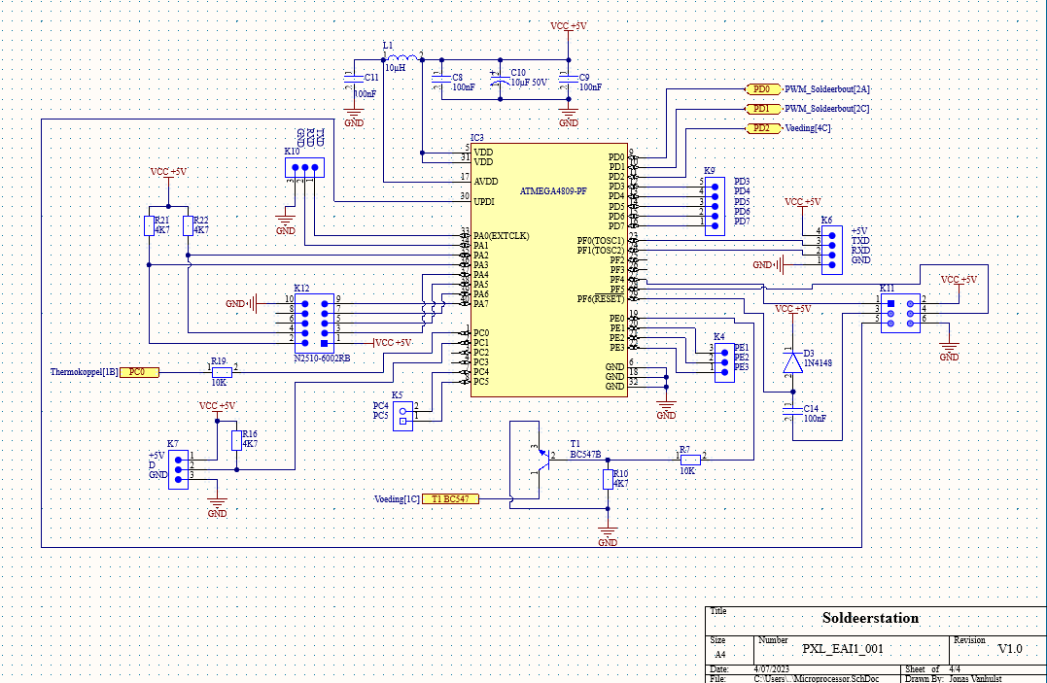

Figure 5 Schematic Design Microprocessor

### Display

In figure 6, the rotary encoder with butten is connected to the TM1636 led driver. This is the main driver that is popular to control the used 7-segment display. The connector K1 is the female connector of K12. This is placed to communicate to the microprocesser.

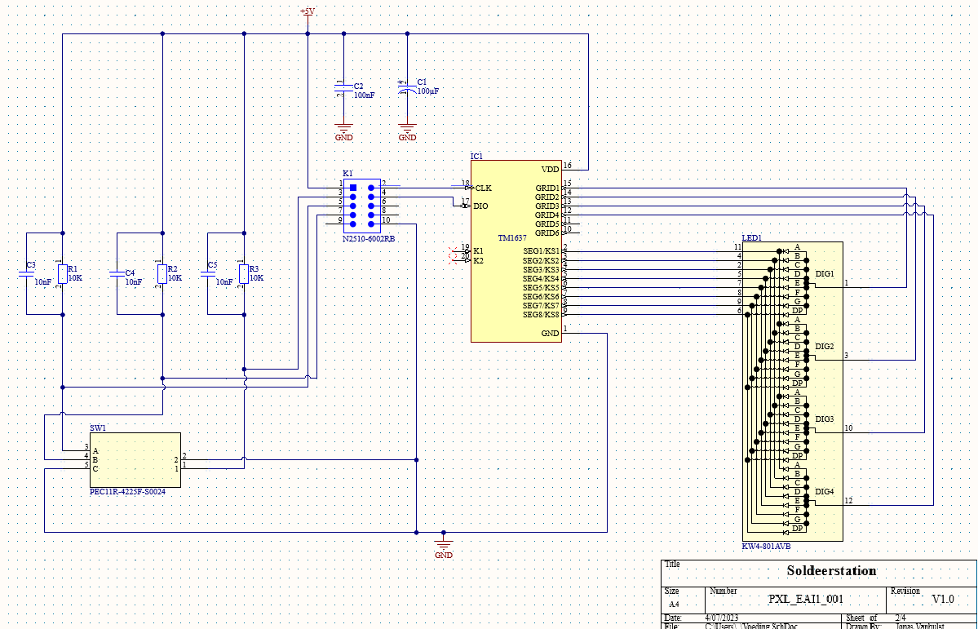

Figure 6: Schematic_Design_Display

### Thermocouple

In the figure 7, all the transistor’s are placed as an open switch. The coil ‘L2’ is used to suppres of the RFI. This is also called as the elektromagnetic interference. If this component isn’t placed in this schematic, the risk of unwanted voltage current will have some consequences.

Figure 7: Schematic_Design_Thermocouple

## PCB Design

### Display

By designing the Display PCB, the rotary encoder and displey needs to be placed on the buttom-layer. The other components are placed on the top-layer to safe space by making the PCB

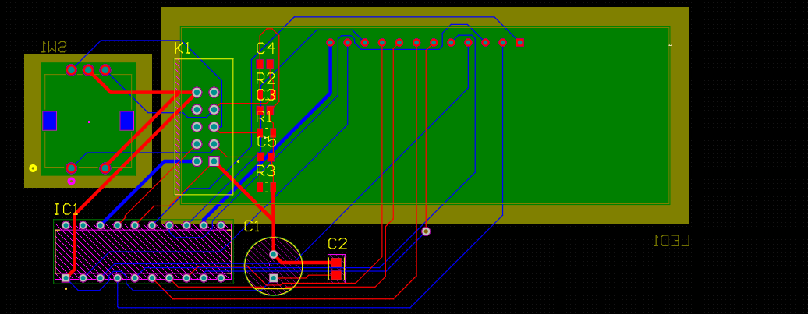

Figure 8: PCB_Desgin_Display

### Processor

By designing this PCB, it was in very important to set capacitor ‘C2’ and ‘C3’ as close as possible to the ‘IC2 Opamp’. This function will be used to reduice the noise on the signal. With the design I came up with two problems. The footprint for ‘B1 & B2’ are not the right ones, to fix this problem I requested the right footprint by ‘Ultra Librarian’. This would take a few day to receive there made footprint. Also the footprint’s of the resitors are failed by importing the right one. By further designing this PCB the Lector told me to set the components as close as possible, so you will have a smaller PCB and this will reduice the prices.

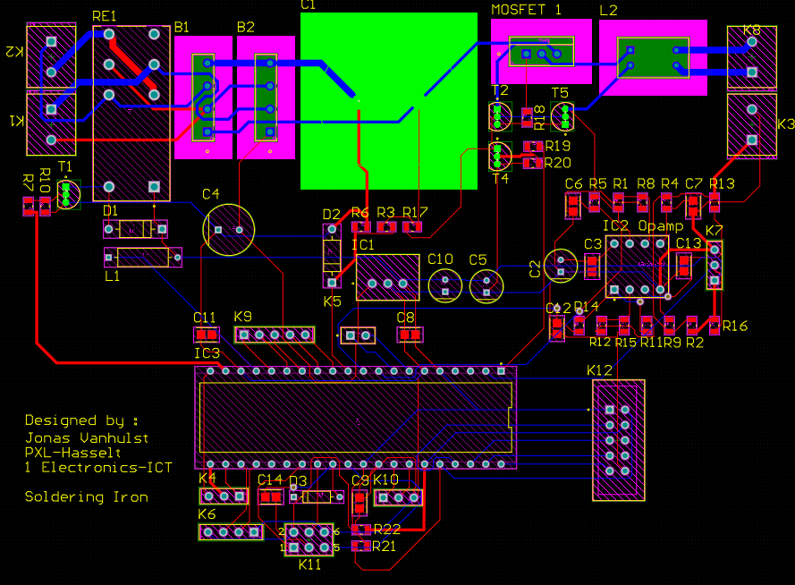

Figure 9: PCB_Design_Processor

### 3D view

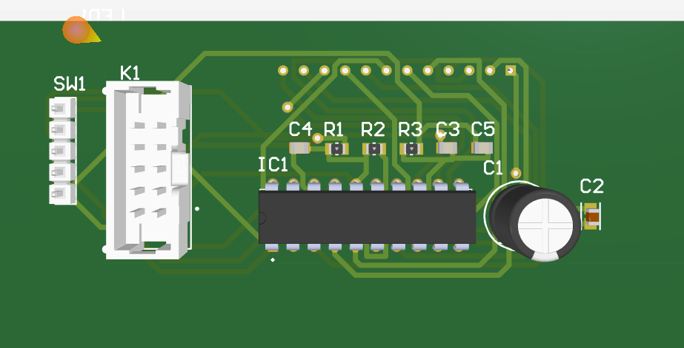

Figure 10 3D_Render_Display

Figure 11 3D_Render_Processor

## Case Design

### Case

For the case design the idea was to make a replica of the fames Wall-E.

### Case and PCB assembly

# Discussion

[Reflect on and discuss your project.

* Which difficulties did you encounter during the design process and why? How did you solve these issues?
* Reflect on the process: did things go as expected? Would you choose the same approach if you had to do the project all over again? Are there issues that still need to be fixed? How come?

**+/-300 words**]

# Reference list

[Insert your reference list here.]